**Categorical Data and One Hot Encoding:**

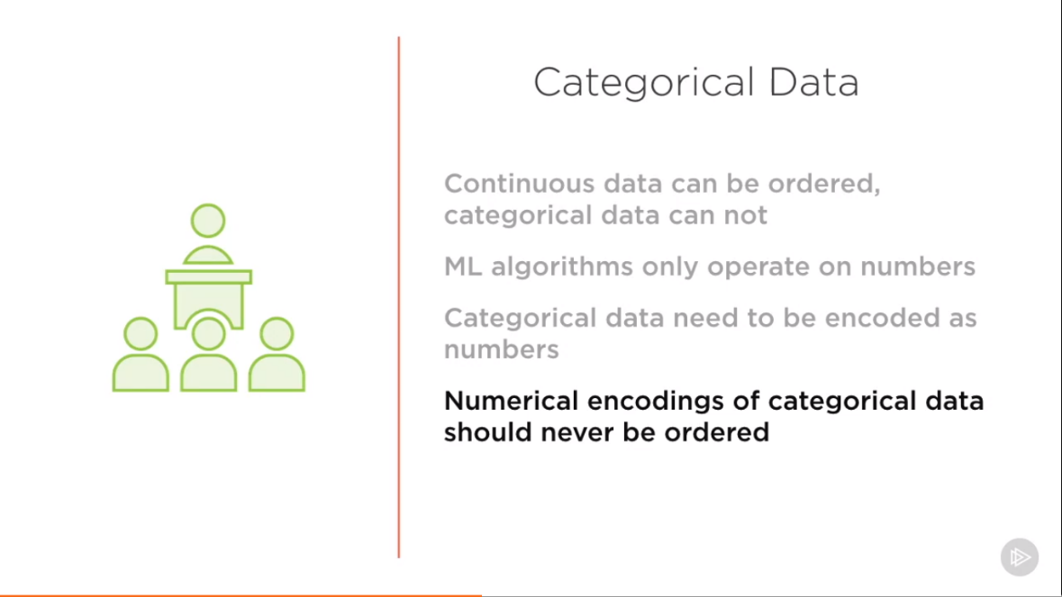

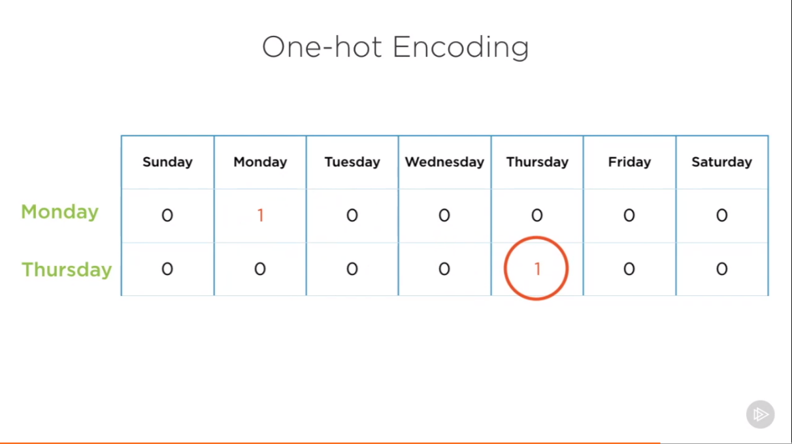

**Representing Numeric Data in Categorical Form:**

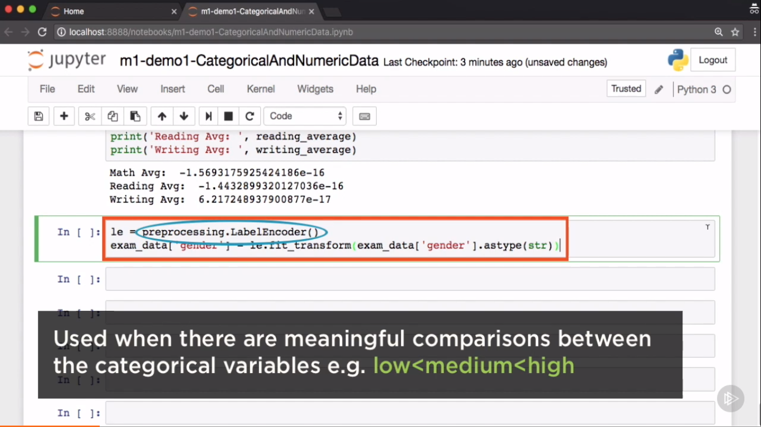

**Encoding Text Data in Numeric Form:**

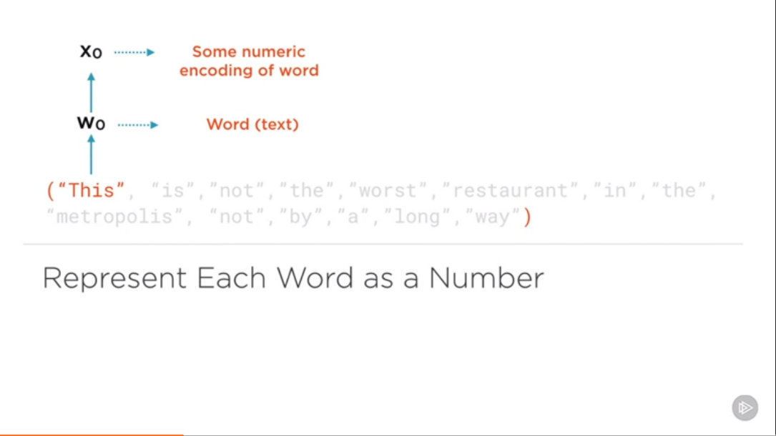

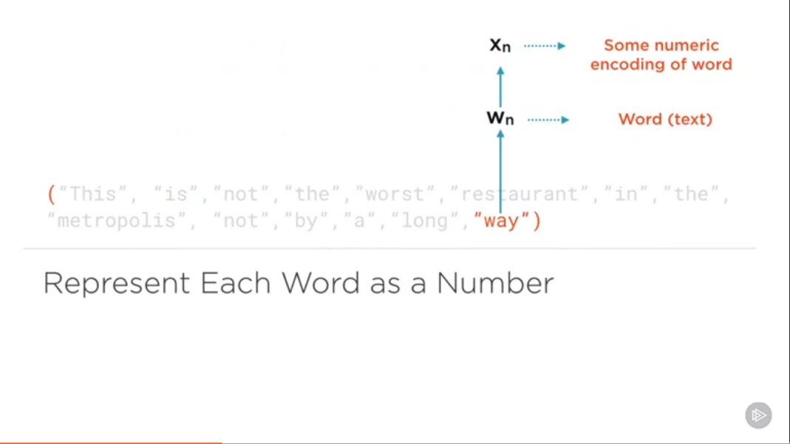

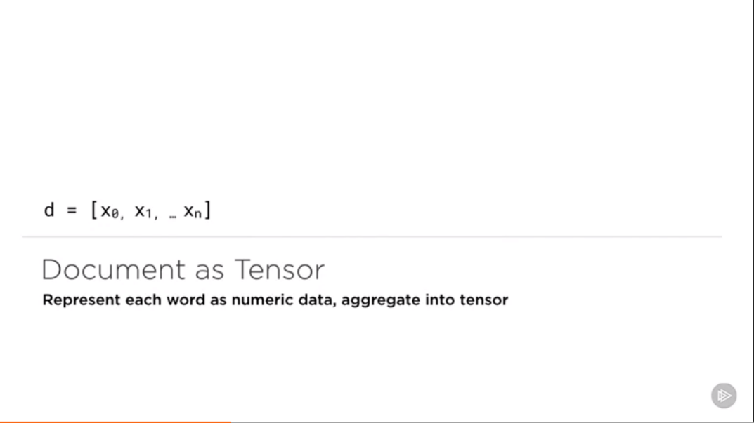

How best can words be represented as numeric data?

**Word Embedding**

* One-hot
* Frequency based
* Prediction based (used in DL specially in Neural network)

**One Hot**

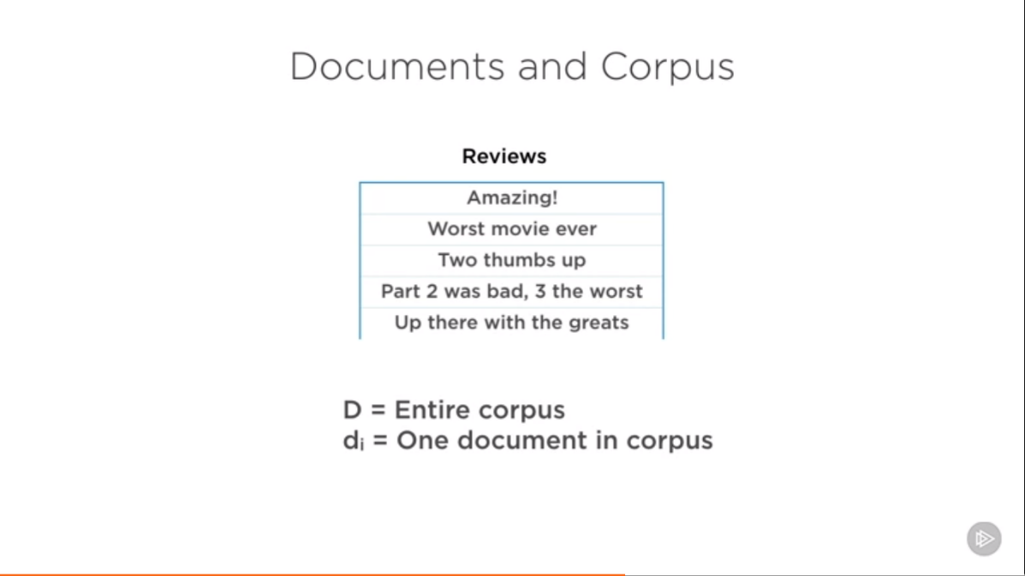

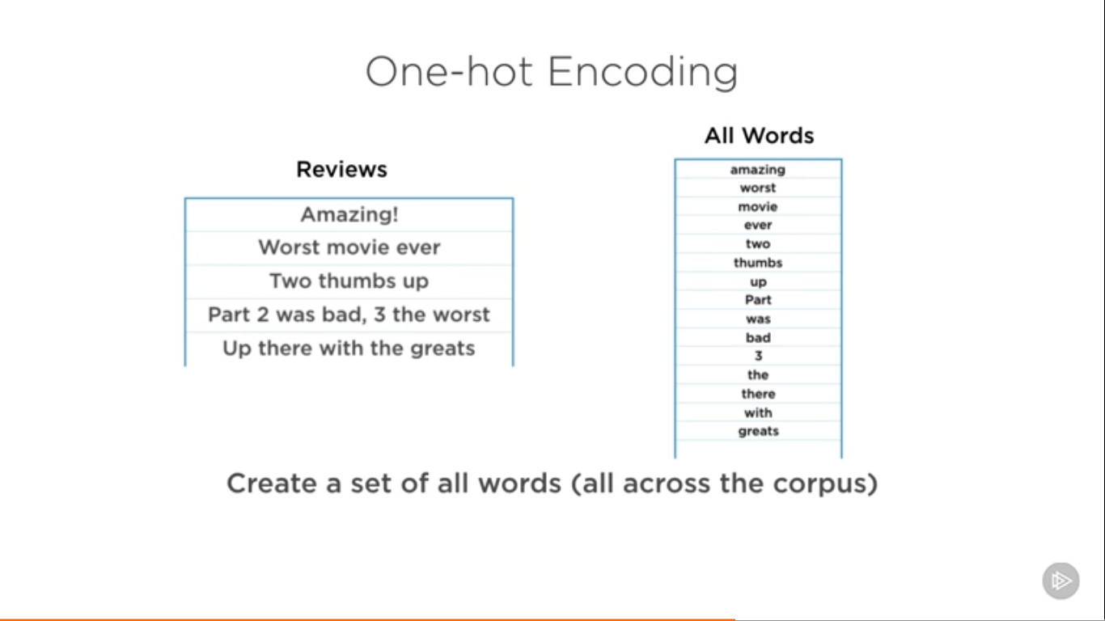

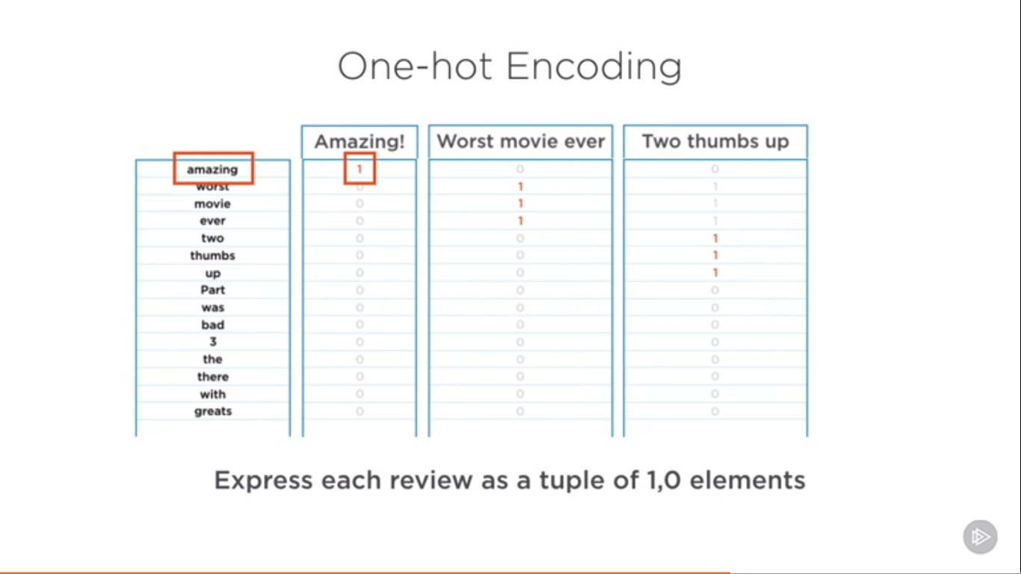

**Flaws of One hot encoding:**

* Large vocabulary – enormous feature vectors
* Unordered – Lost all context
* Lost – Lost Frequency info
* One hot encoding does not capture any semantic information or relationship with words

**Frequency Based Embedding**

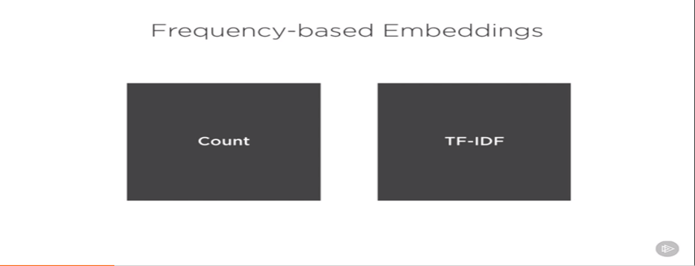

Count captures how often a word occurs in a document i.e. the count or the frequency.

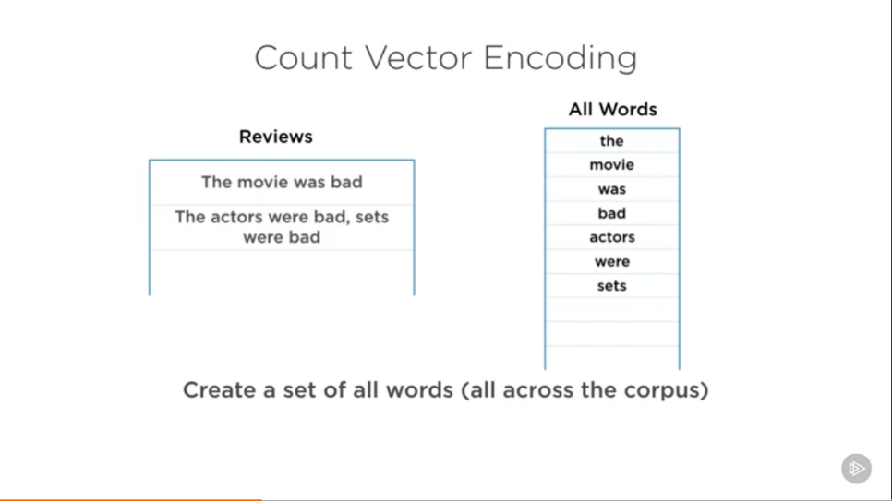

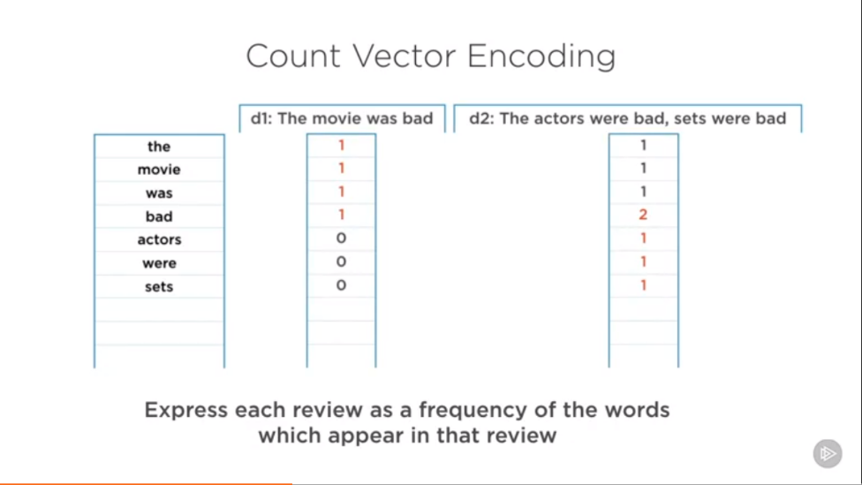

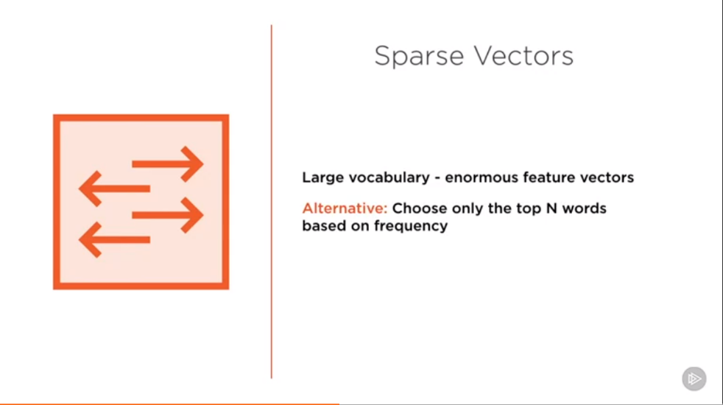

**Flaws:**

* Large vocabulary – enormous feature vectors
* Unordered – lost all context
* Semantics and word relationships lost

Solution for Large Vocabulary

* Hash words to buckets to have a fixed vocabulary size.
* Choose enough buckets so that collision is rare

Ex

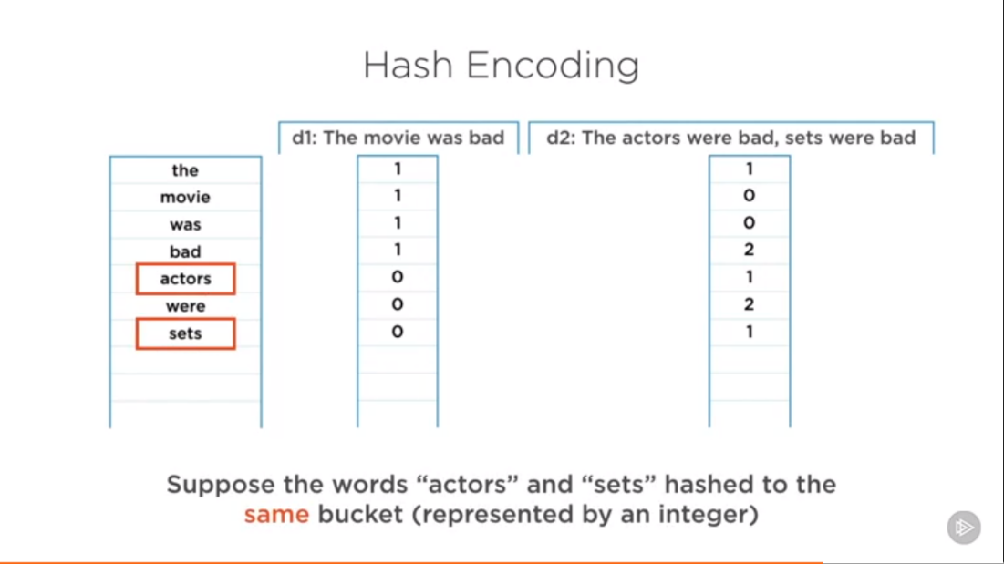

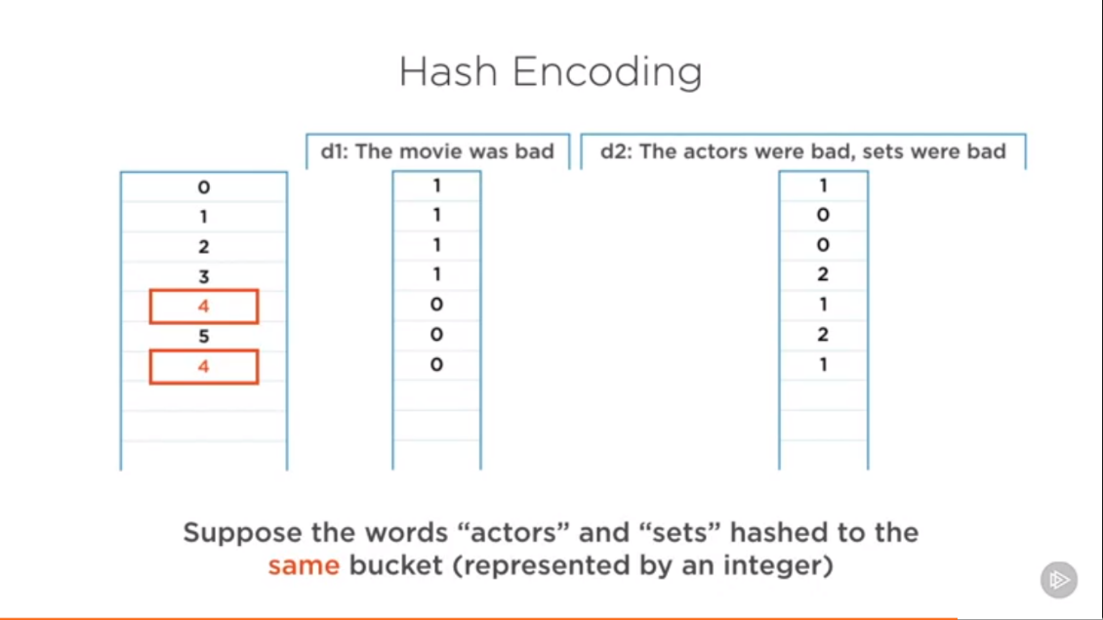

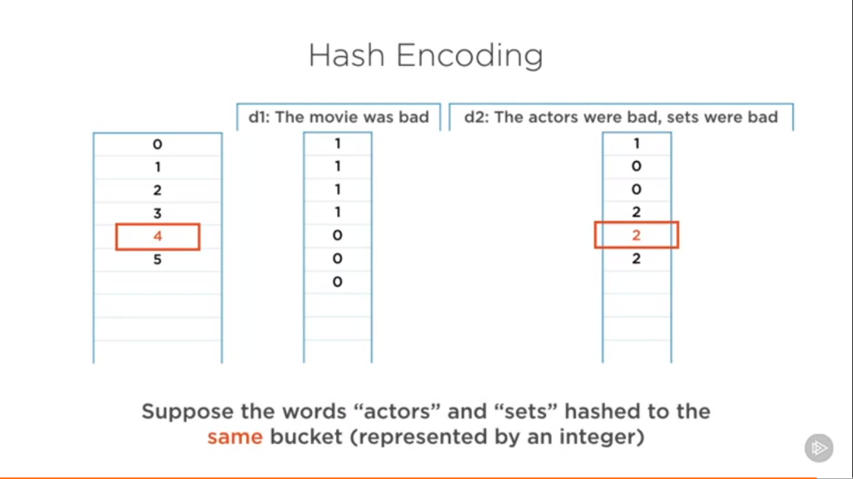

So we lost some info, now we don’t know that these two are different words

**Working of TF/IDF Algorithm:**

It captures two pieces of info – How often a word occurs in a Document as well as the in the entire corpus.

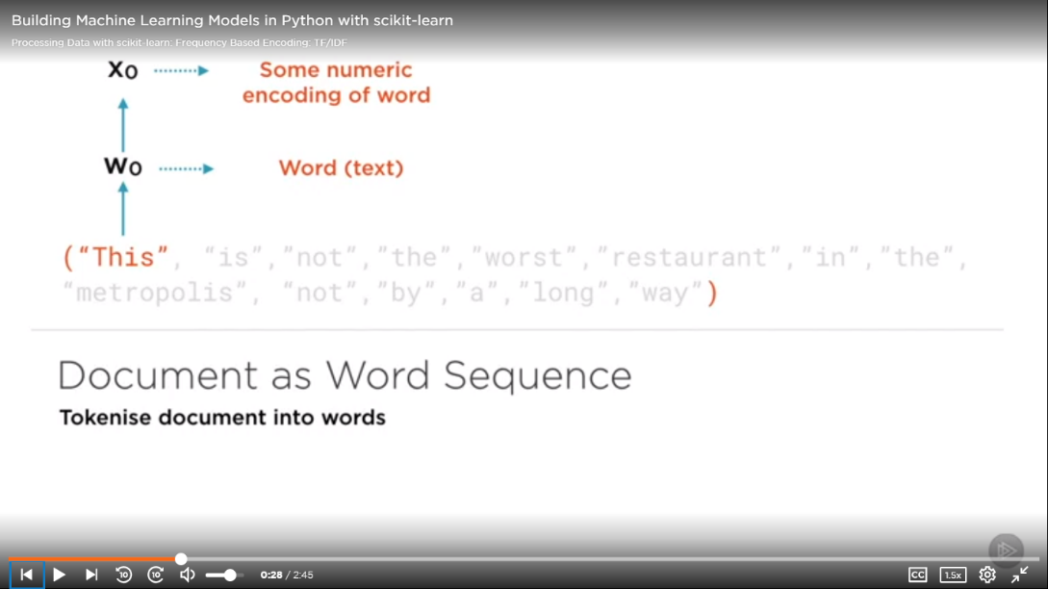

**xi  = tf (wi) * idf(wi)**

**Tf = Term Frequency**

**Idf = Inverse Document frequency**

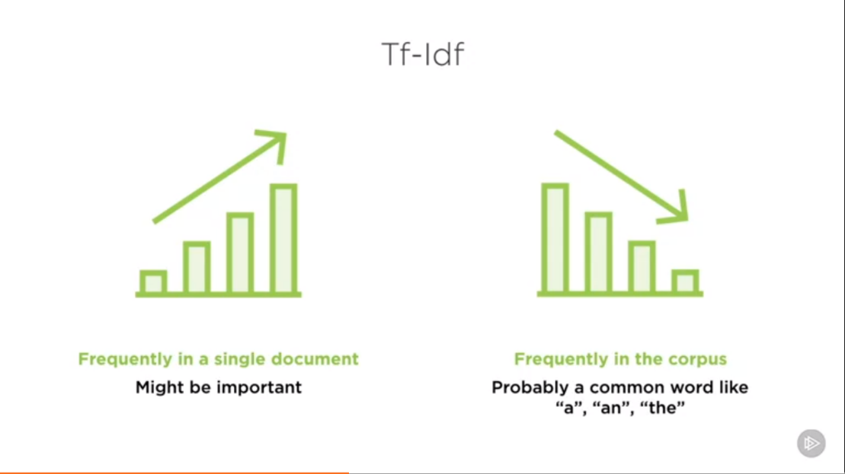

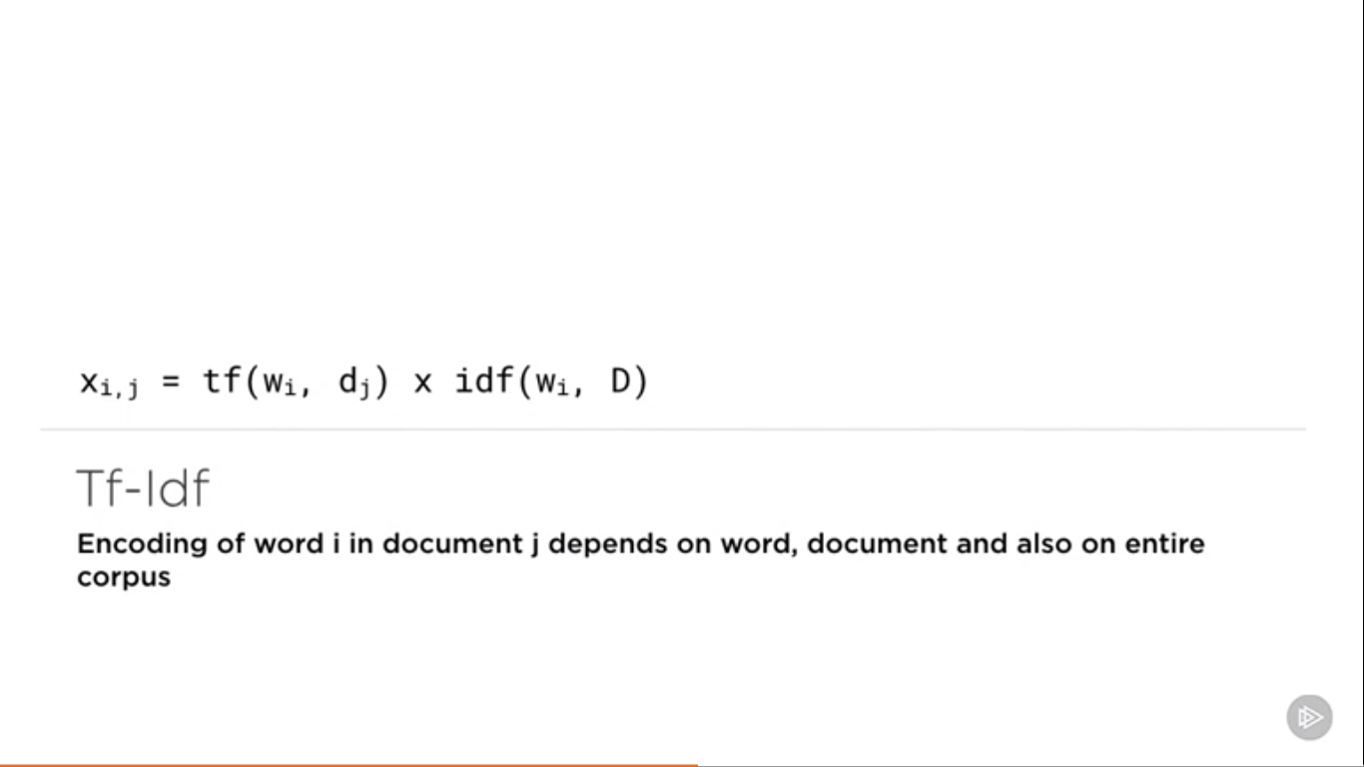

**Tf = Term Frequency**

Measure of how **frequently** word i occurs in document j

**Idf = Inverse Document Frequency**

Measure of how **infrequently** word i occurs in corpus D

**Tf – Idf**

High weight for word i in document j if word occurs a lot in this document, but rarely elsewhere

**Important Advantages:**

* Feature vector much more tractable in size
* Frequency and relevance captured

**One big drawback**

* Context still not captured

**Demo: CountVectorizer, TfidfVectorizer, HashVectorizer:**

**vectorizer.fit(<data>) –** Generate Unique IDs for words in Corpus.

**vectorizer.transform(<data>)** – Assign the generated IDs to Corpus.

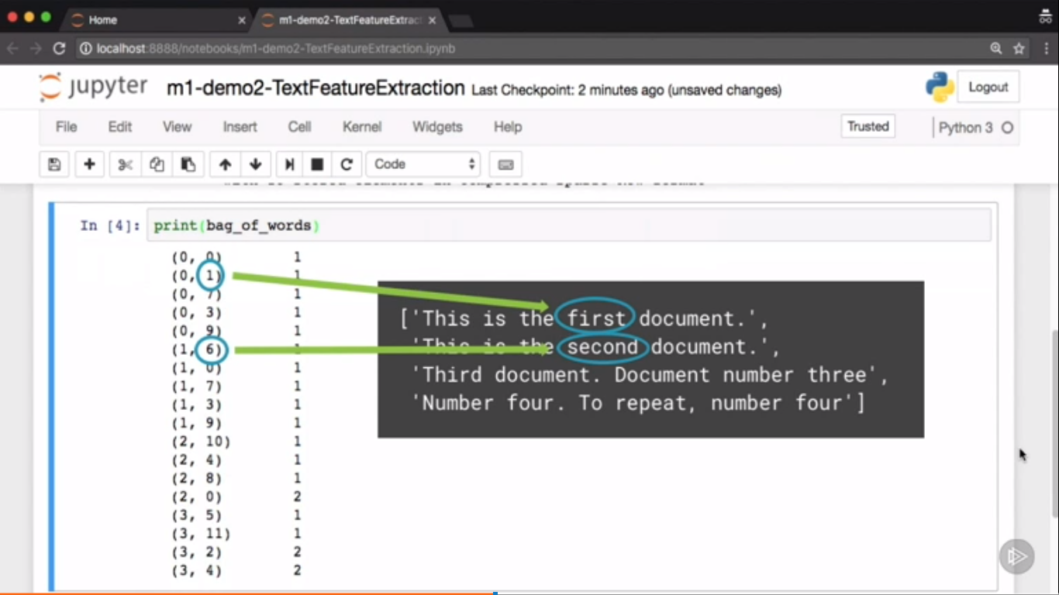

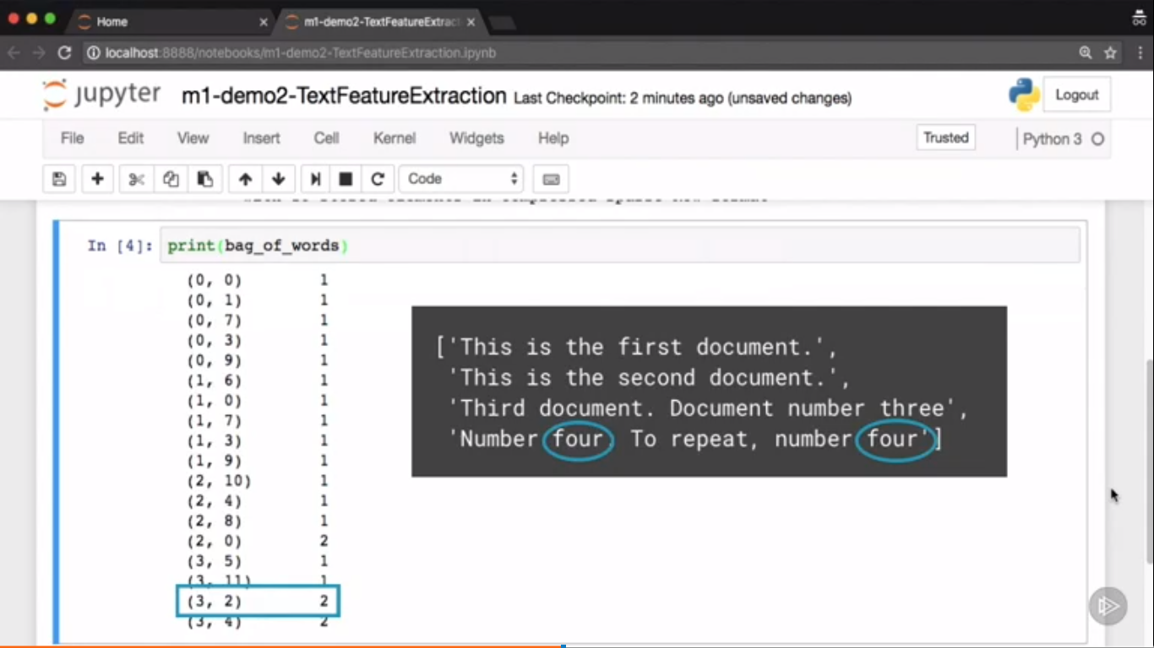

Typically the most occurred words usually get the lower ID

**HashingVectorizer**

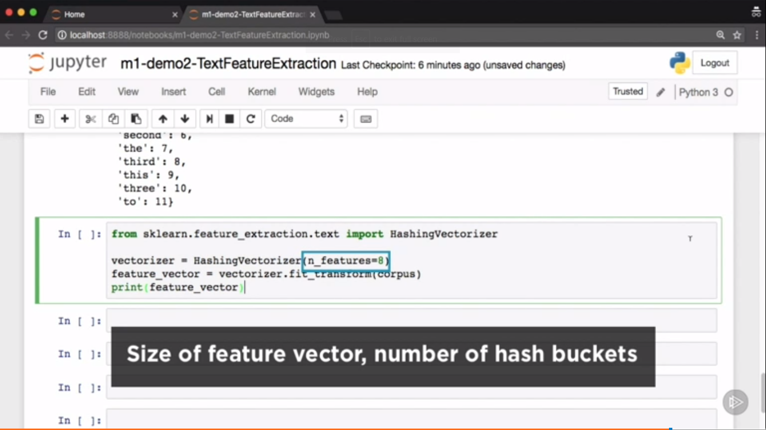

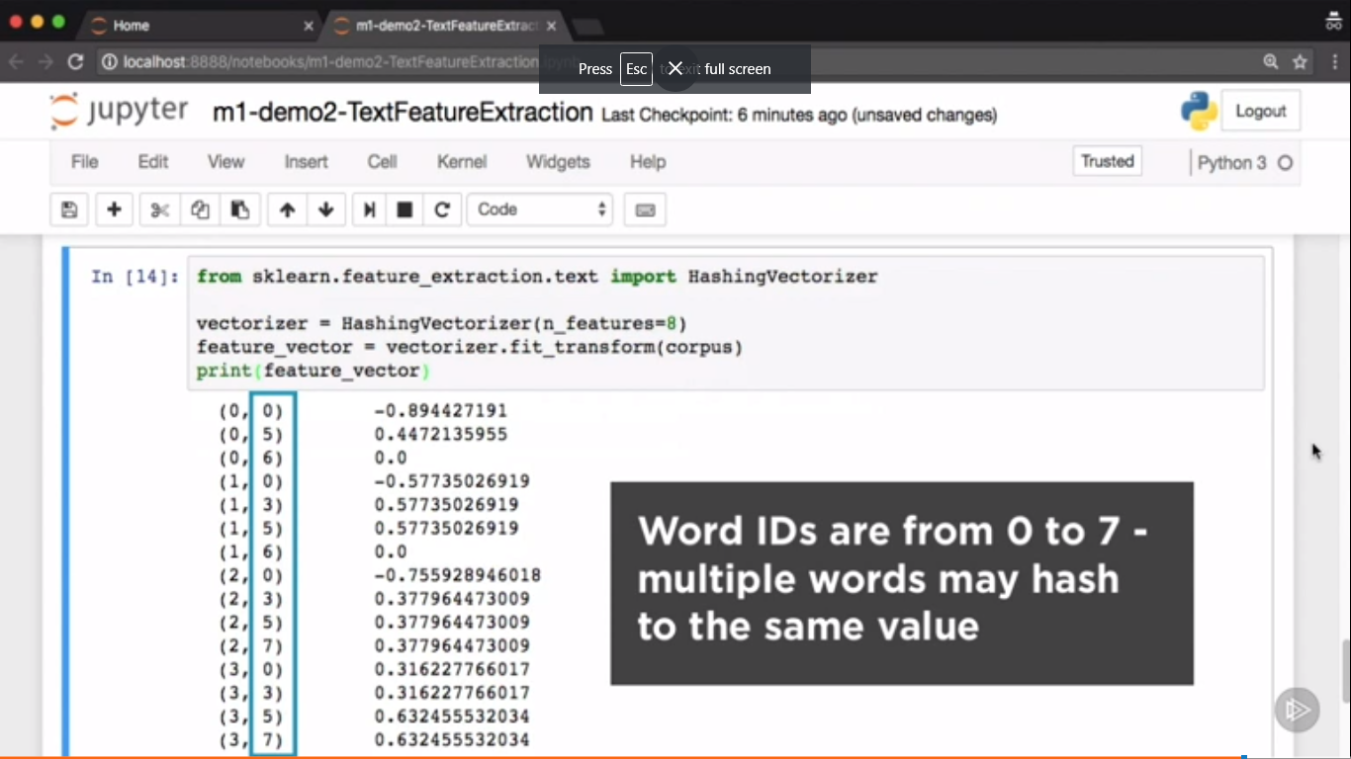

**Representing Images in Numeric Form:**

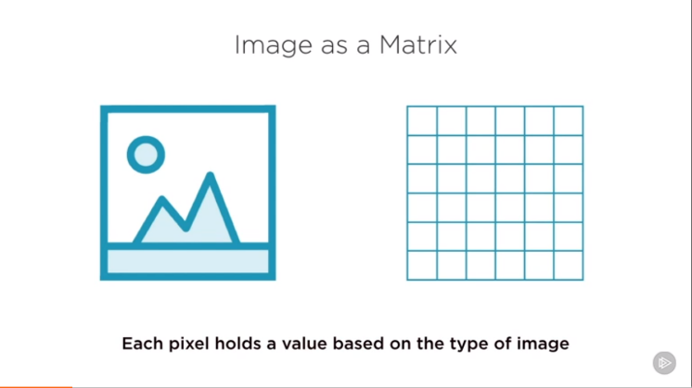

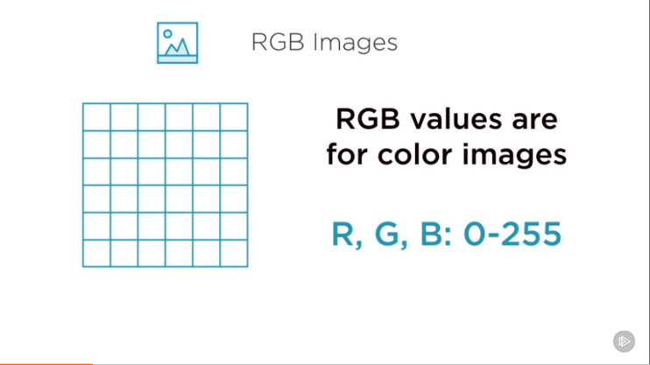

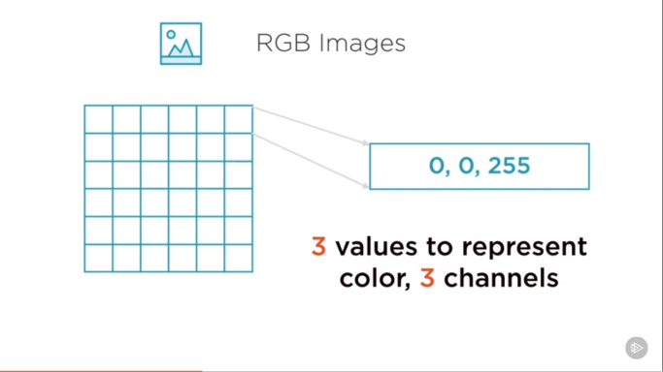

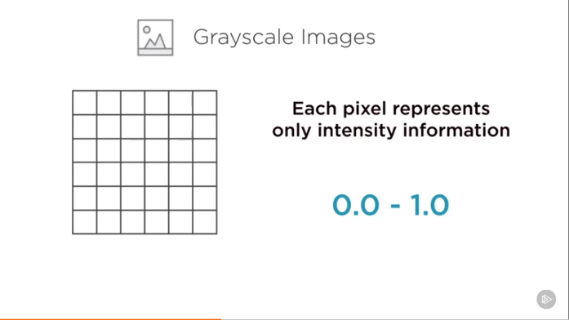

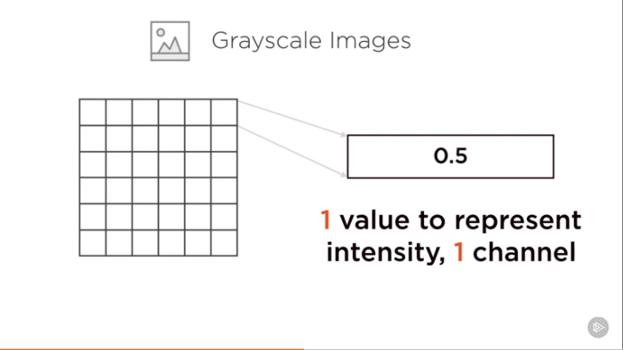

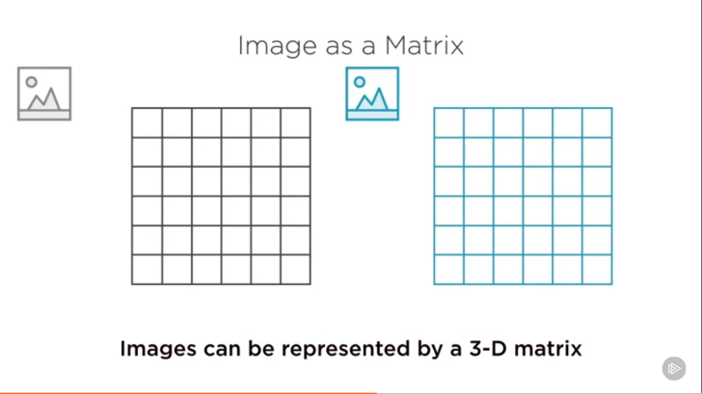

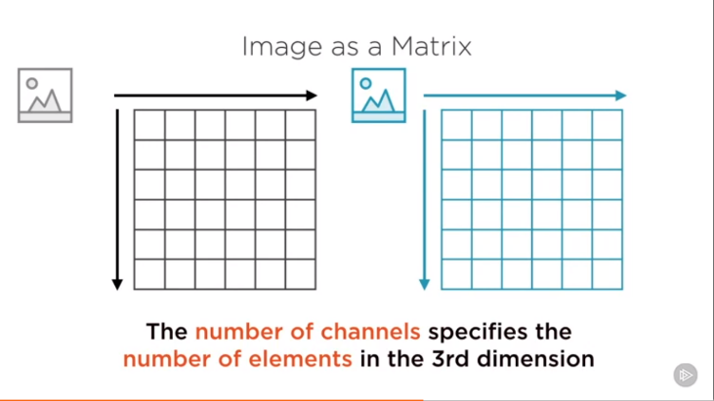

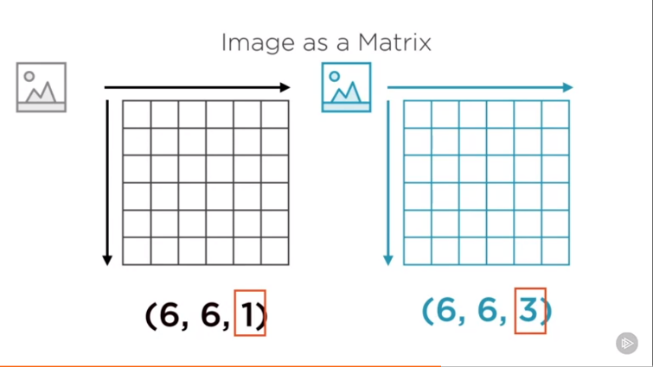

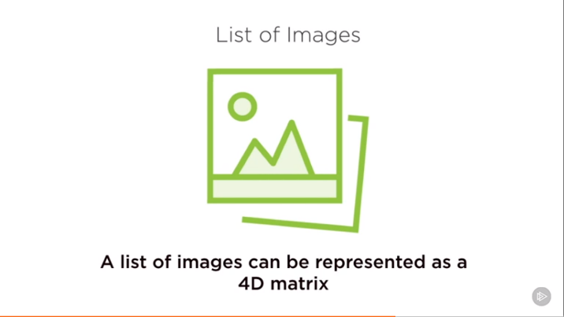

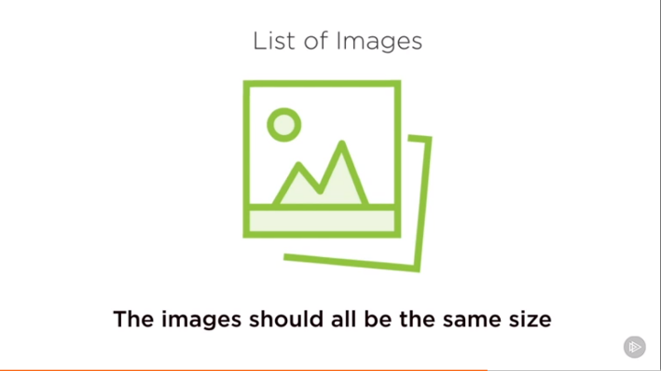

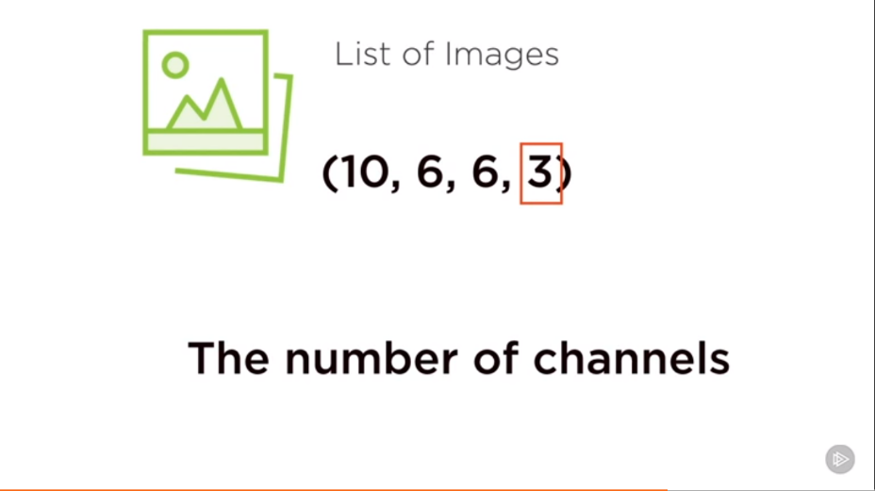

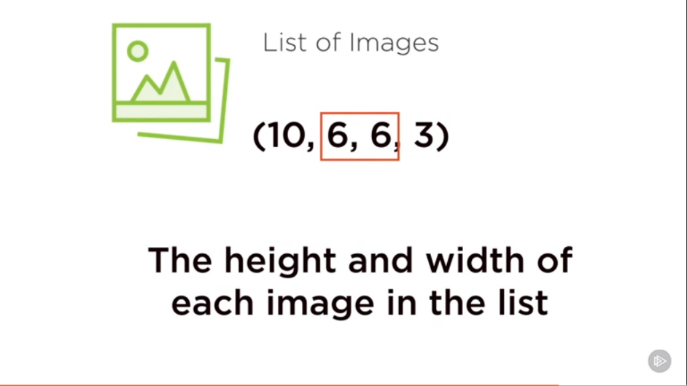

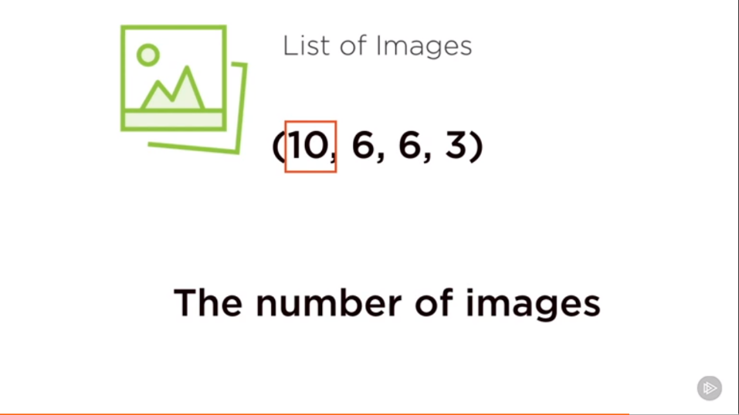

**Demo Extracting Features from image:**

Use the OpenCV library for image processing